Audi RS3 Intercooler Installation

Instructions

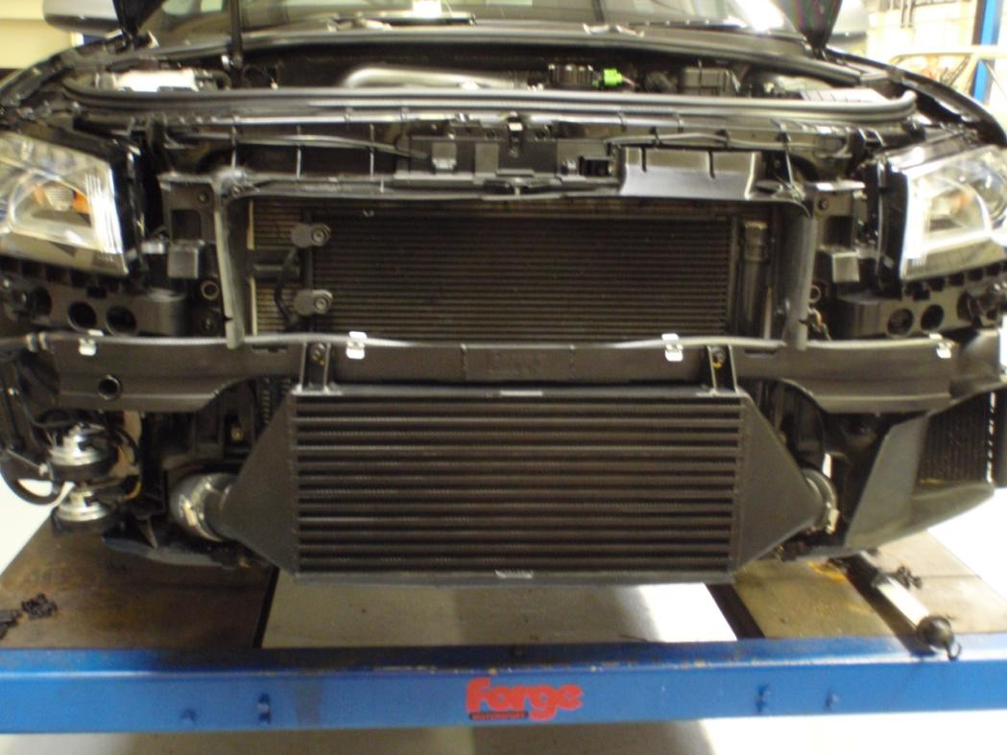

Tools Required:
Flat headed screw driver
T25 Torx driver
T30 Torx driver
10mm deep socket and matching ratchet
Hand drill
Plastic trim remover
7mm hose clamp driver
1. Jack the car up; secure it on axle stands and remove the front wheels to gain excess to the arch liners. Undo the T25 torx screws and pull out the inner part of plastic clips and remove.

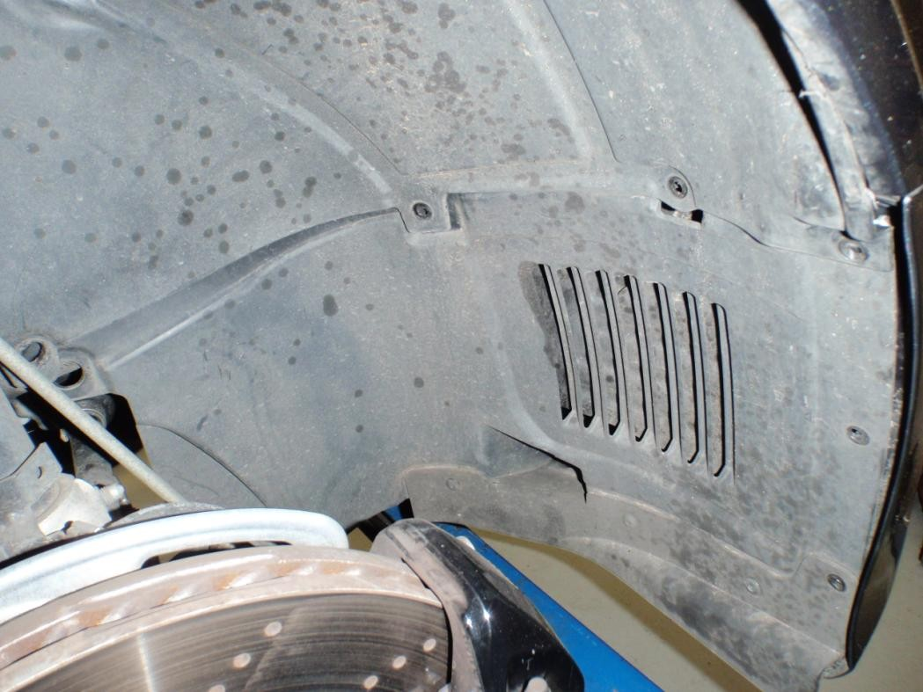Plastic clip

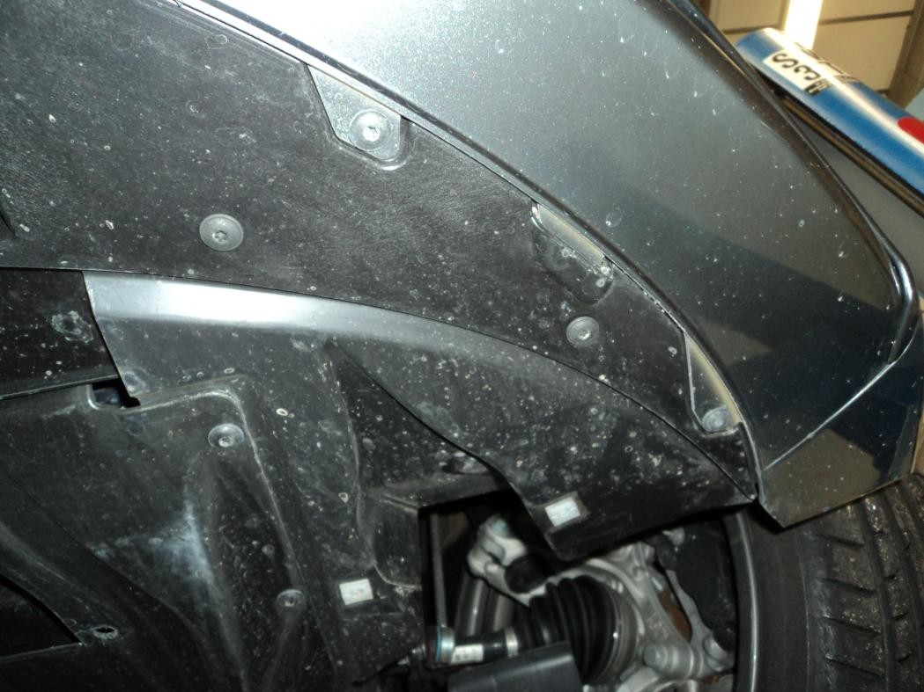2. Undo the T25 torx screws under the front bumper and remove the arch liner.
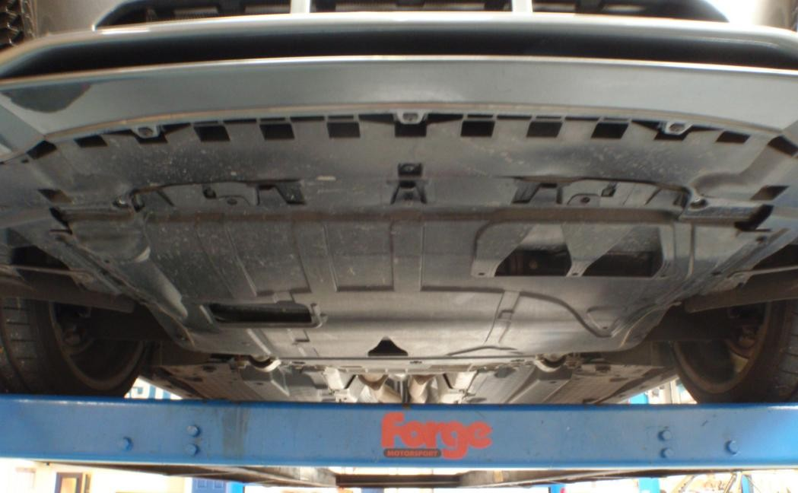3. Undo the three T30 torx screws at the rear of the under tray then undo the T25 torx screws from the front and sides and remove.

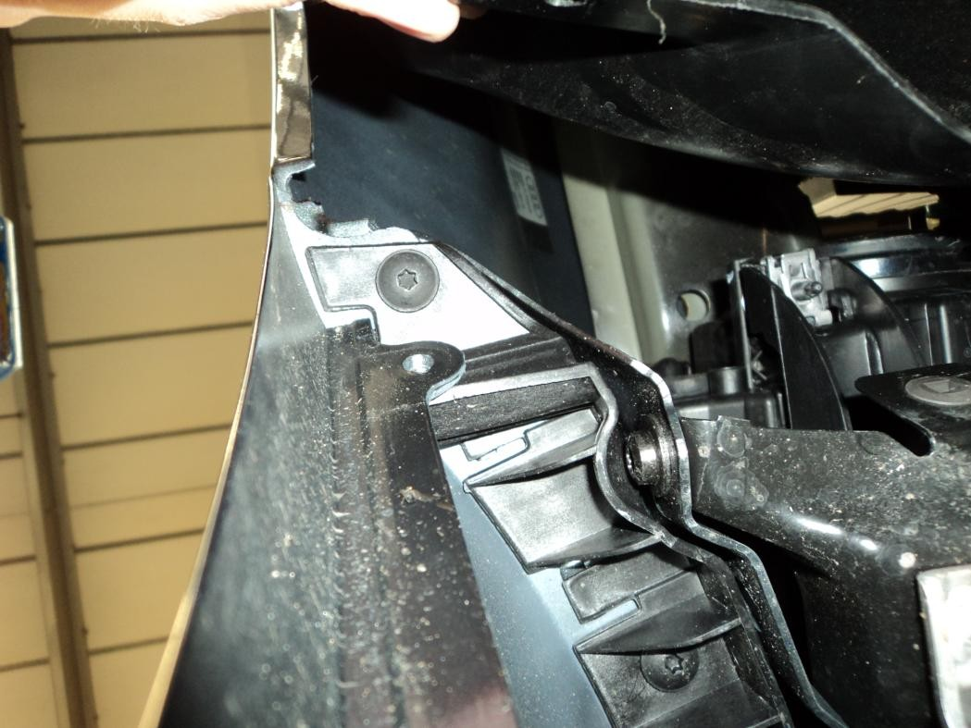4. Moving back to the inner arch, remove the T25 torx screws from the plastic bracket holding the bumper to the wing.
5. Remove the 13mm bolt from the back of the light - this is hard to see and reach but you can access from the inner arch.

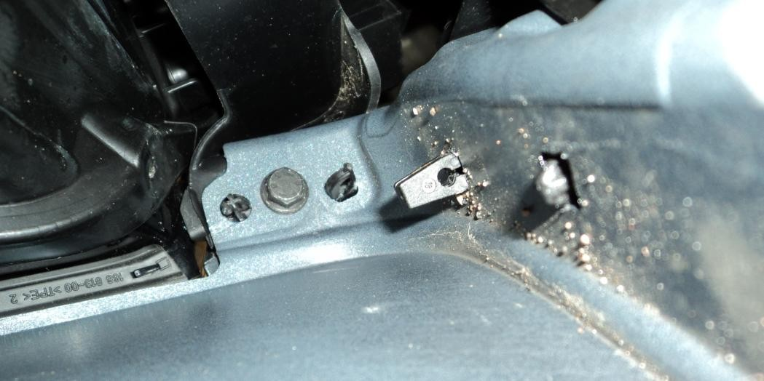

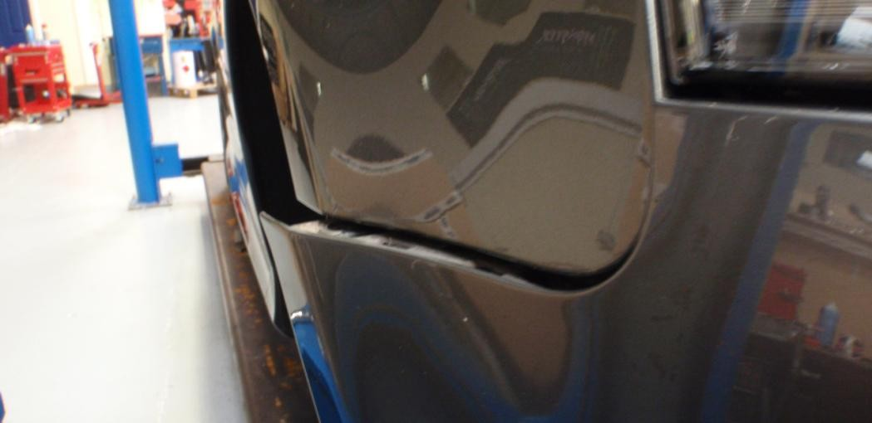6. Pull the bumper out at the sides.

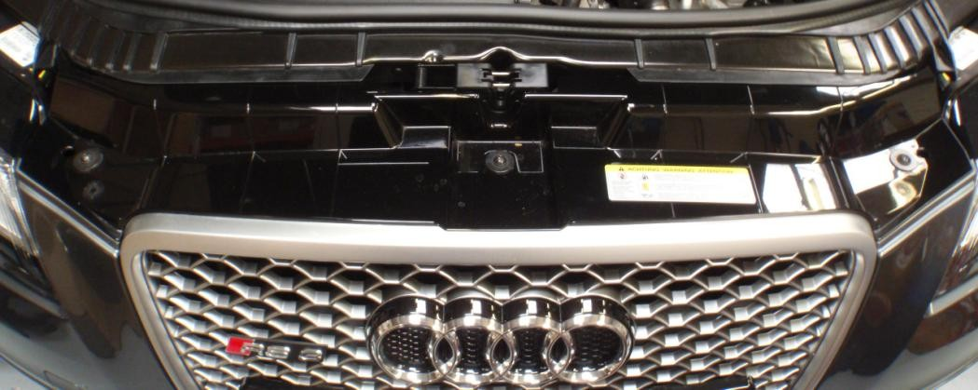7. Moving to the front of the vehicle, remove the T30 torx screws and remove the bumper.
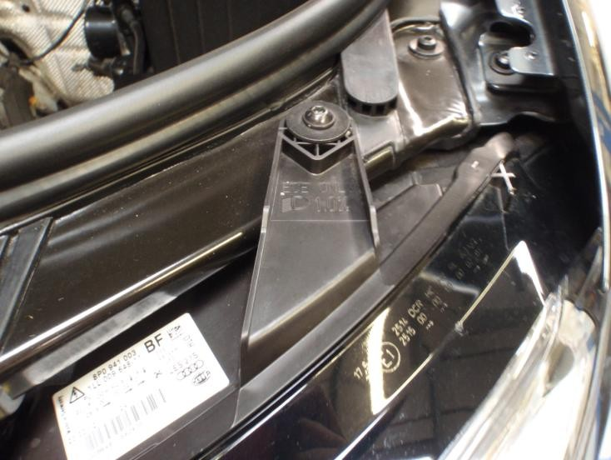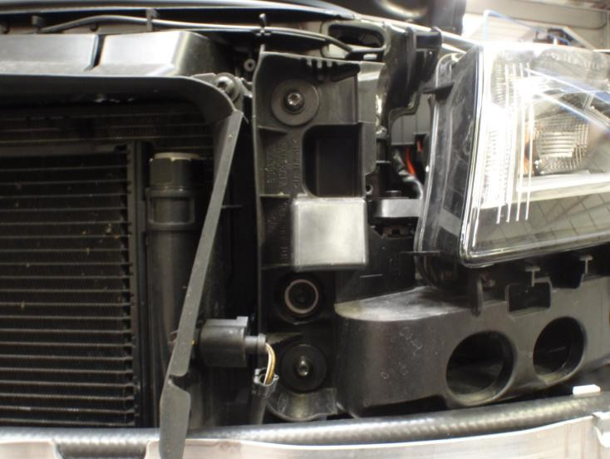8. Undo the jubilee clips on the intercooler and undo the T30 torx screws on the top and bottom brackets. Keep the top bolts to one side as they are reused on the new
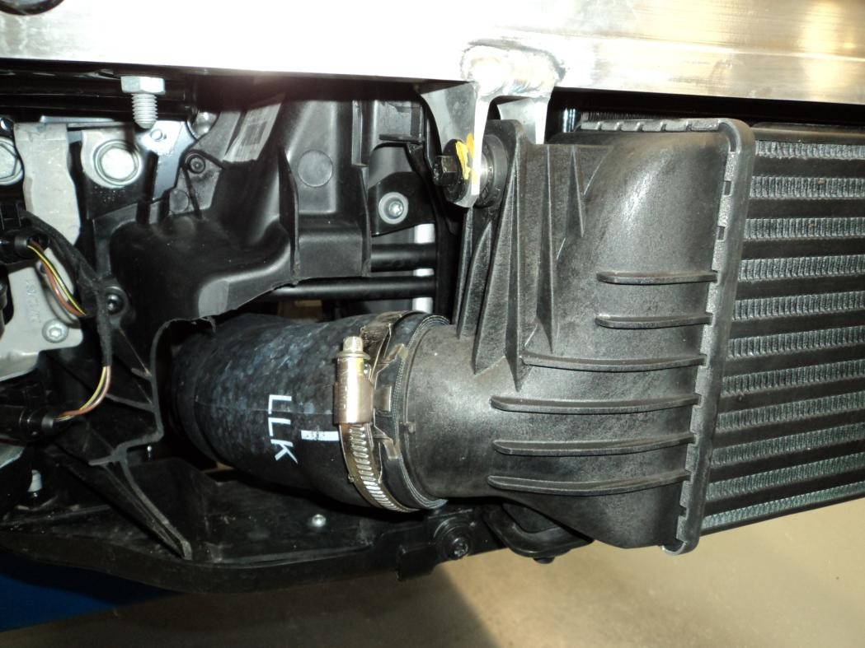intercooler.

9. The lights need to be removed to gain access to the bolts on the crash bar by undoing the T30 torx screws.
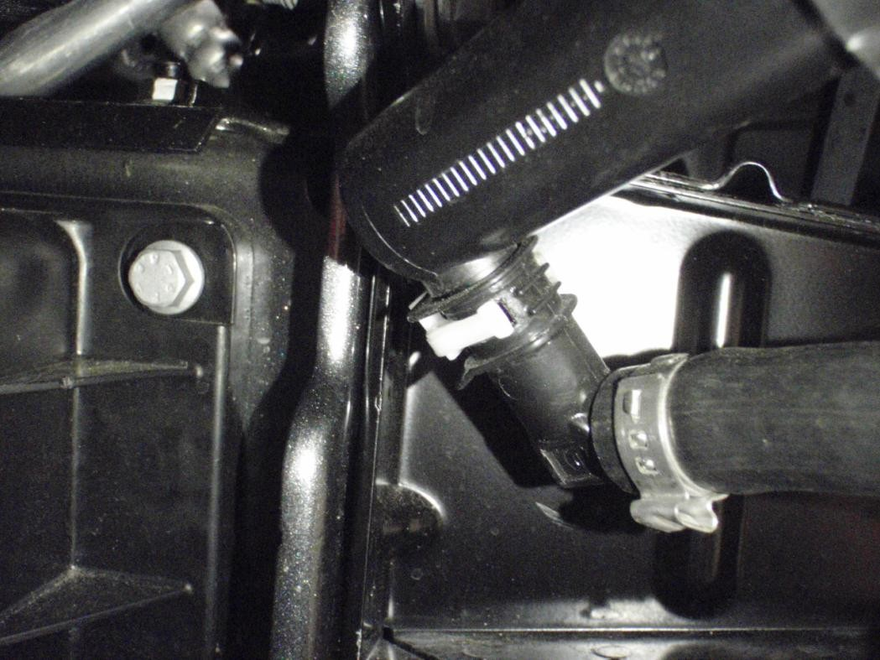10. Unclip the head light washers and pull off the pipe.

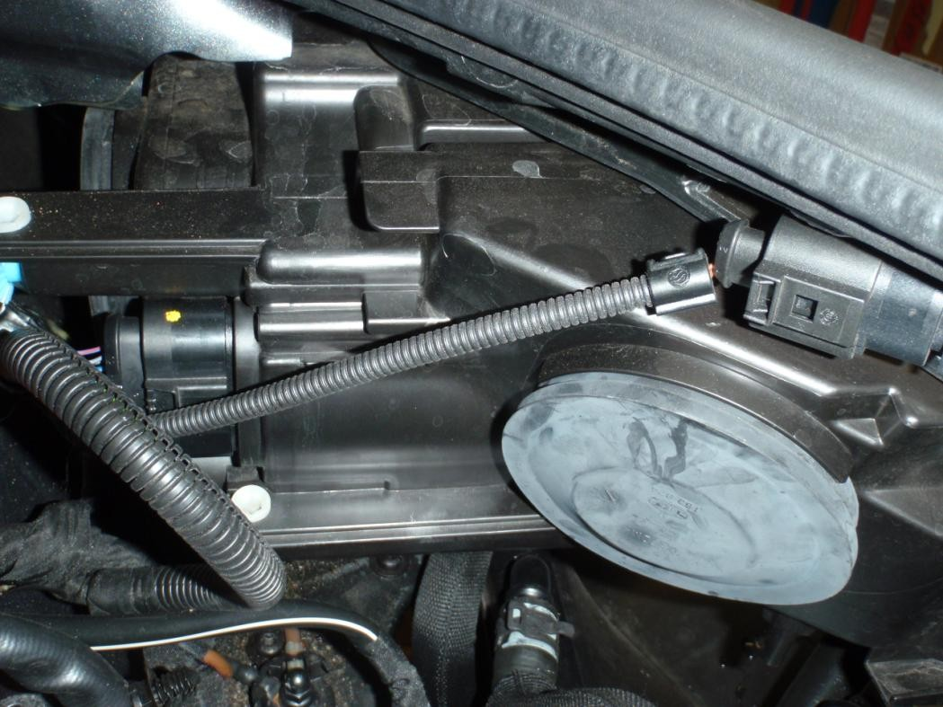11. Pull the headlights out slightly and remove the electrical plug and remove completely.
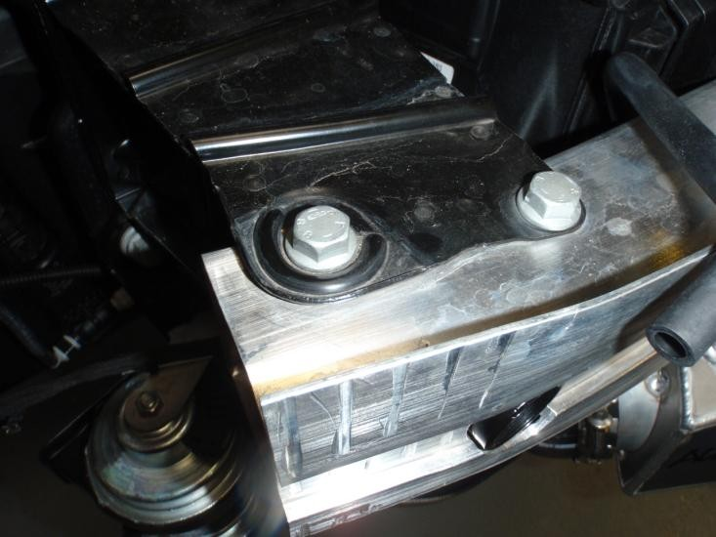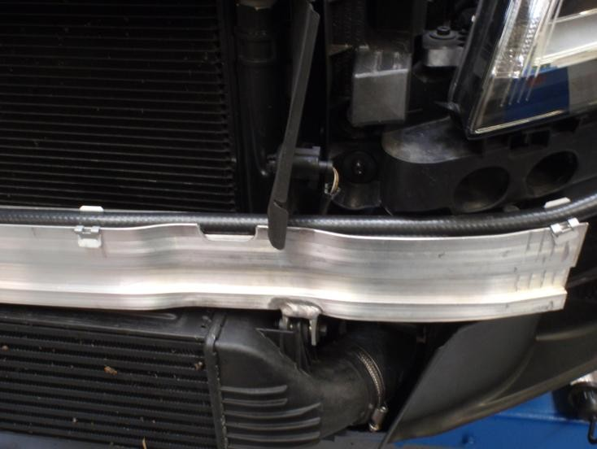12. Unclip the headlight washer pipe work, undo the two bolts at each end and remove the crash bar. Install the extra capacity crash bar using the bolts just removed and reattach the washer pipe work.

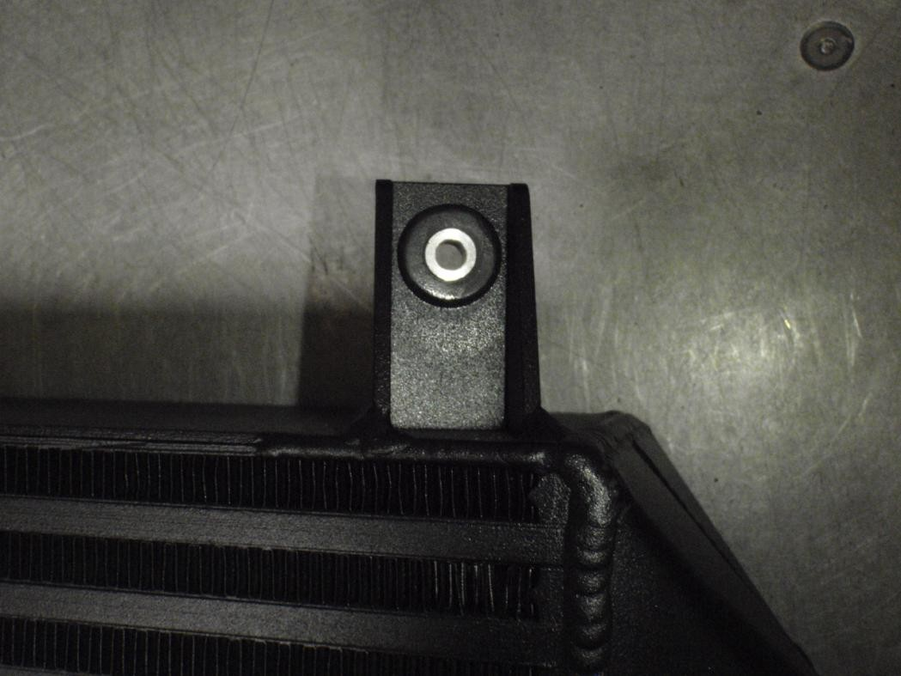13. Insert the rubber grommets and aluminium sleeves into the intercooler, these are supplied in the kit.
14. Place the uprated intercooler in position, attach the hoses and replace the existing intercooler brackets.

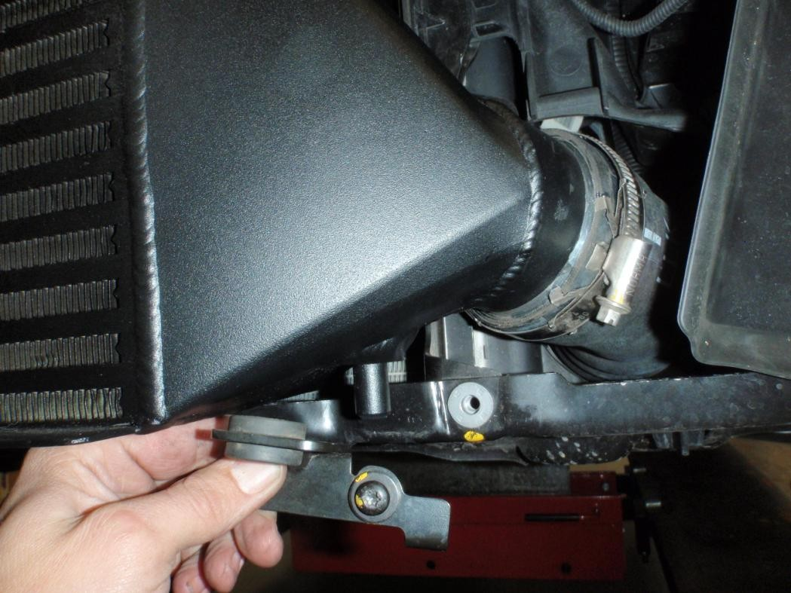

15. Now the intercooler is in the correct position, lift up the washer pipe out of the way.
Drill two holes with a 6mm drill bit through the grommet inserts. Using the bolts
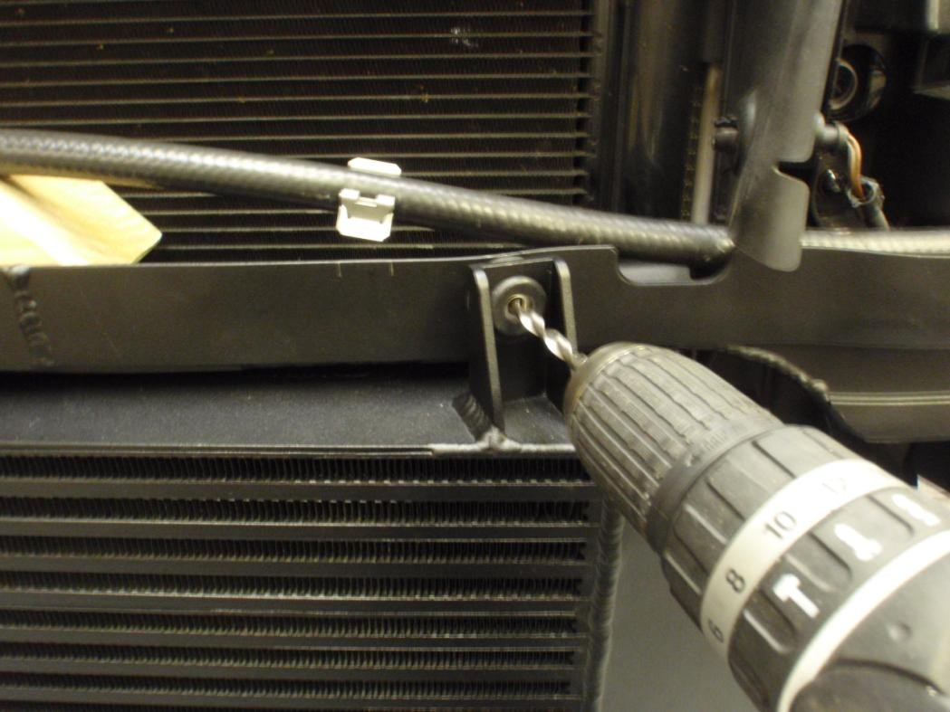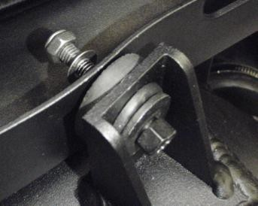from the OEM intercooler and the nuts and washers supplied, attach the intercooler.
16. The front and back part of the number plate trim needs to be removed. Remove the foam from the inside of the bumper. Also remove the bottom piece of foam
for clearance on the new intercooler. These will not be refitted.

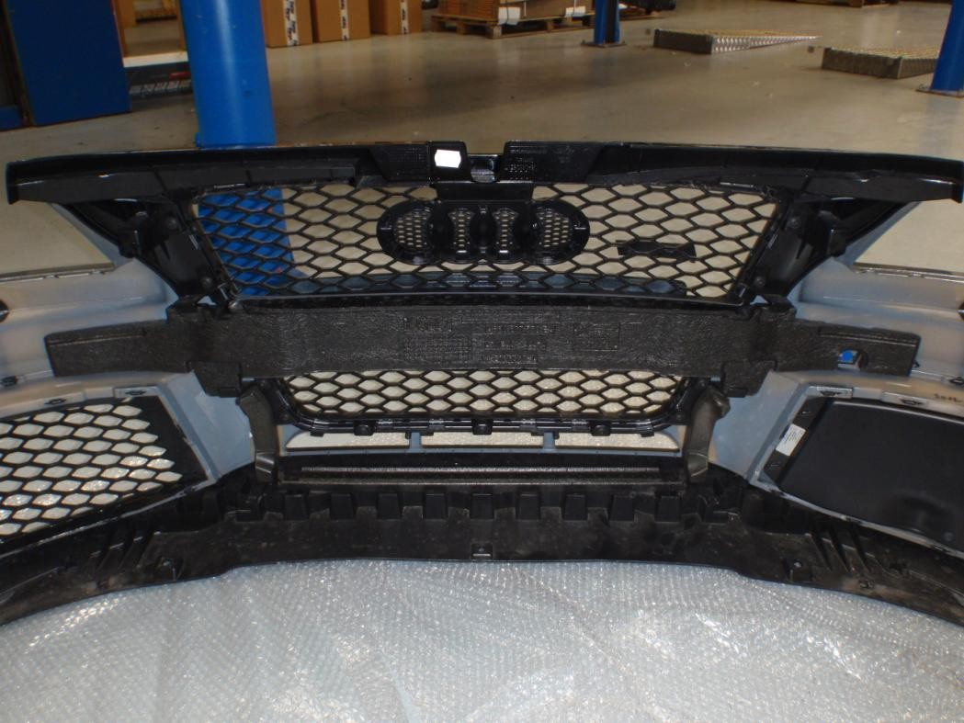Remove foam

Remove foam

17. Unscrew the number plate then unscrew the number plate surround. Remove
the front and back part of the trim.

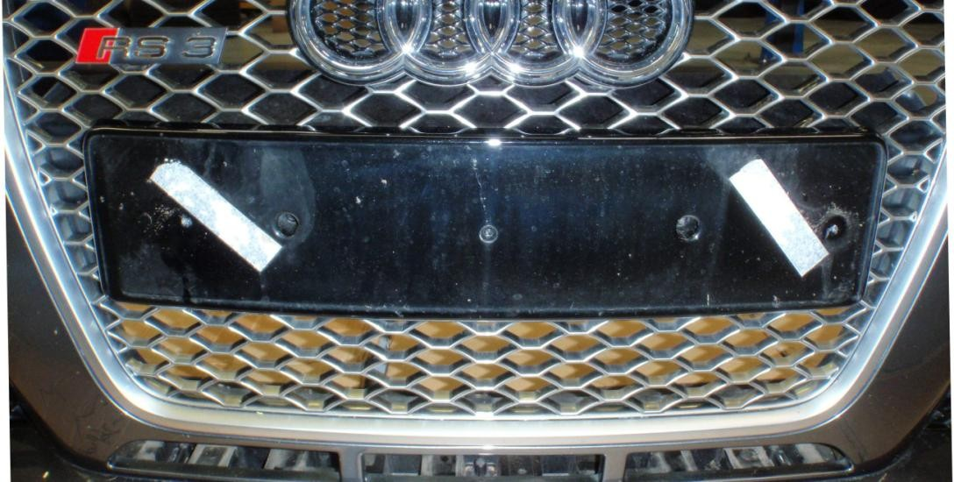Unscrew
18. Place the two discs with one hole in the center behind the grill, and the two discs with two holes in front of the grill into the correct position as shown below. Using the counter sunk bolts, fix in position.

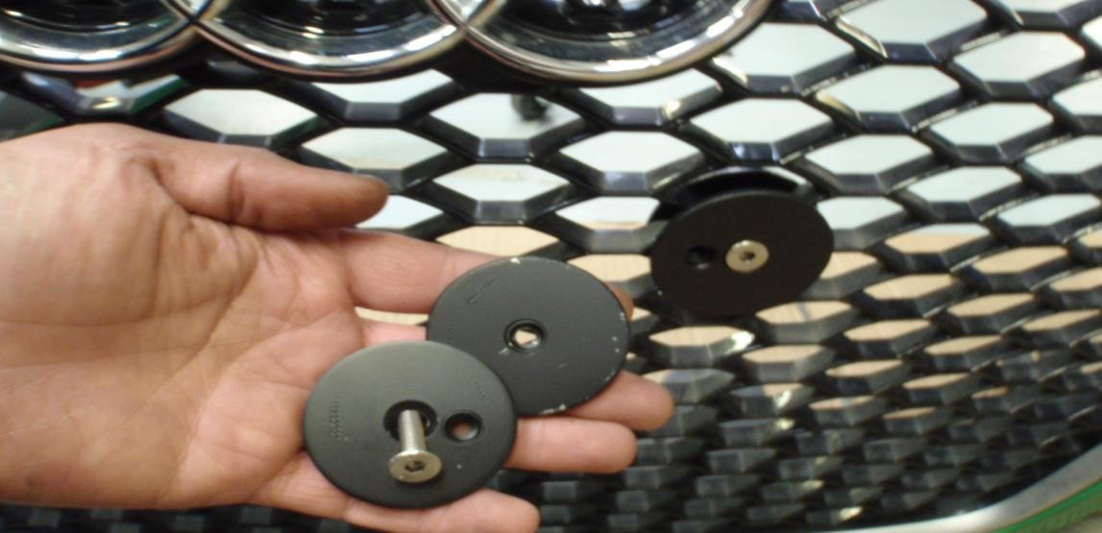
19. Measure between the new number plate fixings and transfer onto the number plate. Drill new holes or move the disc’s around until they match up with the existing holes.

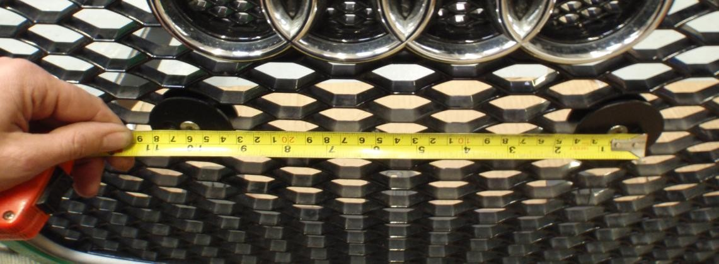

20. Using the button head bolts, install the number plate.

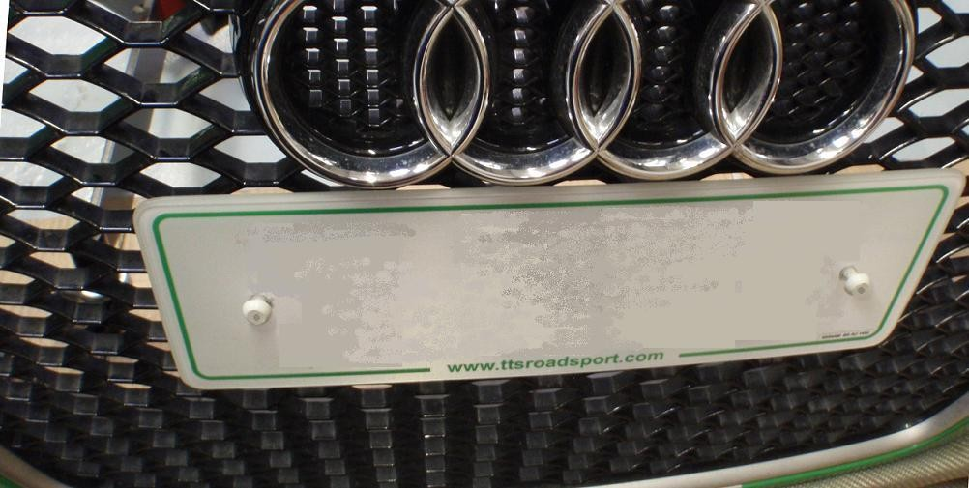
21. Now follow steps 1 to 11 in reverse and your installation is complete.

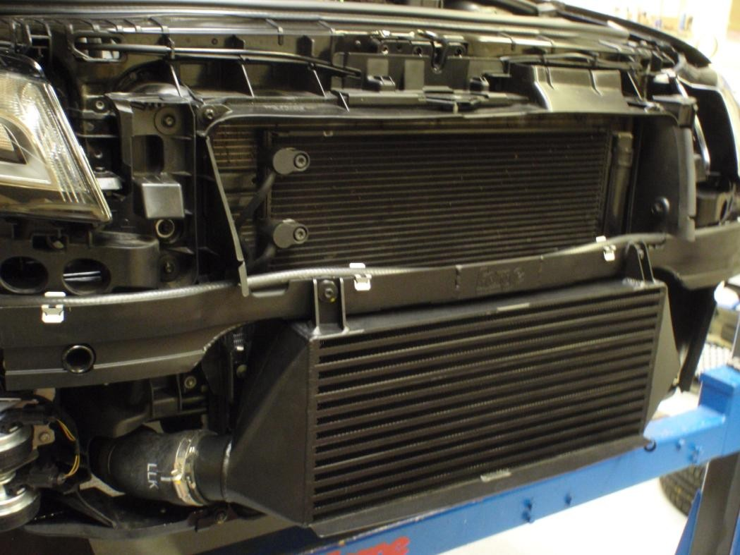

You may also be interested in these other Forge products for the Audi RS3, available from your nearest Forge dealer or direct from Forge:

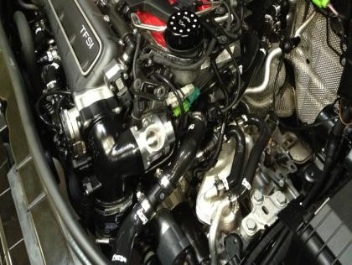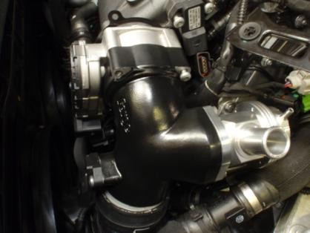

High Flow BOV and Inlet Pipe
Silicon Hoses

ENGINEERED FOR PERFORMANCE

